FORMAL ANALYSIS #2

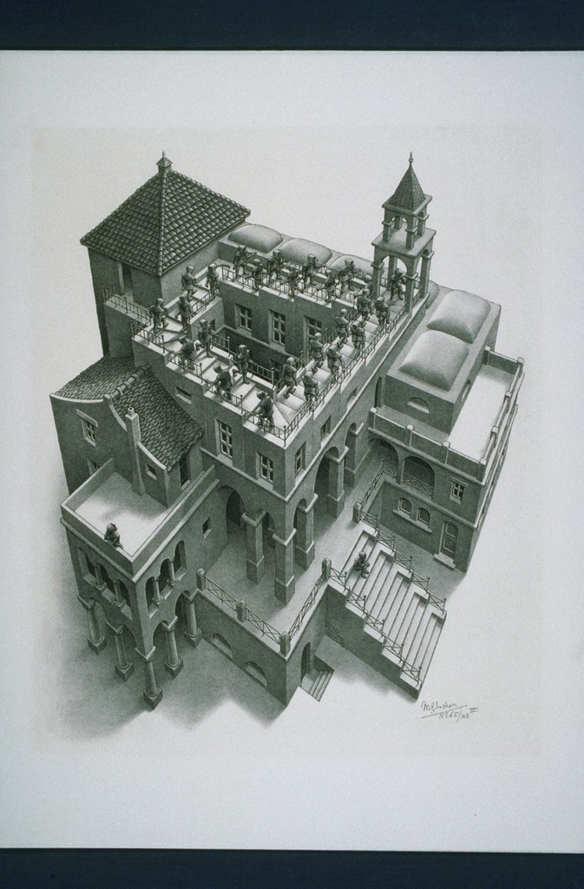

*Fig. 1.* Maurits Cornelis Escher, *Ascending Descending*, 1960, Lithograph, 35.5 cm × 28.5 cm, Davis Museum and Cultural Center, Wellesley College,

In the twentieth century M. C. Escher rose in popularity throughout the artistic, mathematical, and popular world for his works of art. Escher’s work was primarily focused around lithographs, woodcuts and mezzotints. The lithograph, *Ascending Descending*, first printed in 1960 is one of his most popular, and my favorite pieces. The Dutch graphic artists lived from the 17th of June 1898 to the 27th of March 1972. During his time, he produced hundreds of pieces of modern art with the most notable being, *hand with Reflecting Sphere (1935), Relativity (1953),* and *Waterfall (1961)*. Escher was mathematically inspired yet he believed he had no mathematical ability. Complex geometry, explorations on infinity and symmetry are hallmarks of his work. M. C. Escher produced lithographs that neglected the physical limitations of realistic artworks by bending the world to his will. Mixing the impossible and possible, he produced mathematically inspired pieces with wide popularity only to be long neglected in his day in age.

*Ascending Descending* evokes a dreary reality with the monks locked in a never-ending cycle of Repetition. *Repetition works with pattern to make the artwork seem active. The repetition of elements of design creates unity within the artwork.* The monks prominently embody this element of repetition, although you cannot analysis this piece without discussing the “unknown” sect’s own qualities. The colorless sect suggests a sturdy and strong foundation with sets of columns and arches. This foundation translates to the monks, creating unity and a feeling of order throughout.

Escher’s emphasis on the ascending and descending staircase highlights another element, Movement. *The path the viewers eye takes through the artwork, often to focal areas. Such movement can be direct along lines edges, shape and color within the artwork*. The sense of energy within the lithograph is created by the cluster of monks in a droning, repetitive walk. The ascending monks posture convey a message contrary to that of the descending. With the slumped ascending figures passing on the left of the upright descending. The differential posture creates a sense of realism within the piece contrary to the impossible shape the figures are situated on.

Escher centers the piece around the impossible staircase but does not fail to include other features. The monks resting on the balcony and the staircase create Balance. *The distribution of the visual weight of objects, color, texture, and space. If the design was a scale these elements should be balanced to make a design, feel stable…* Although *Ascending Descending* is positioned heavily towards the top of the lithograph, these two monks pull your attention to the visual perspective. The piece strongly indicates perspective with the building’s sharp edges, long columns, and wide staircases. This pull of the perspective and the movement discussed above create the balance between human activity and the “unknown” sect.

Maurits Cornelis Escher built an impressive and incredible portfolio over the course of his life. *Ascending Descending* holds its own place with its use of repetition, movement, balance, and much more. The dynamic nature of this piece coupled with its unrealistic features make it hard to turn away from. Following the monks going round and round the Penrose stairs on their determined path, the viewer if forced to think about their place in the piece. Are you watching from the balcony or gazing off into the blank background like the monk on the stairs? Regardless, it is difficult for us to interpret so we must simply marvel at Escher's utterly impossible world.

Work Cited.

“Ascending and Descending.” *Escher in Het Paleis*, 2 Jan. 2020, [www.escherinhetpaleis.nl/escher-today/ascending-and-descending/?lang=en](http://www.escherinhetpaleis.nl/escher-today/ascending-and-descending/?lang=en).

“Ascending and Descending.” *Wikipedia*, Wikimedia Foundation, 6 Dec. 2019, en.wikipedia.org/wiki/Ascending_and_Descending.